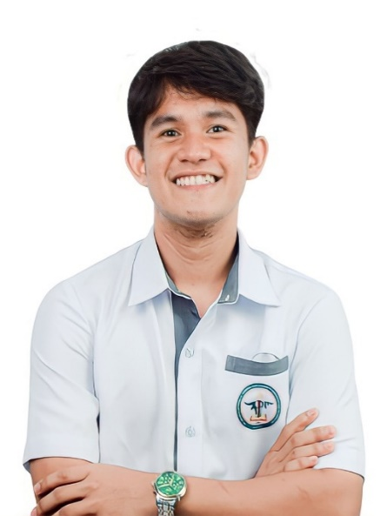

RESUME

JOHN RAVE R. ARIZOBAL

**Poblacion, Aroroy, Masbate 09197034423**

[**johnravearizobal28@gmail.com**](mailto:johnravearizobal28@gmail.com)

**PERSONAL INFORMATION**

**Sex :** Male

**Birthdate :** July 11 , 2003

**Place of Birth :** Gaid, Dimasalang, Masbate

**Civil Status :** Single

**Nationality :** Filipino

**Religion :** Roman Catholic

**Father’s Name :** Arnel O. Arizobal

**Occupation :** Barber

**Mother’ s Name :** Rhea R. Arizobal

**Occupation :** Vendor

**EDUCATIONAL BACKGROUND**

**Tertiary** August 2022 - Present

Dr. Emilio B. Espinosa Sr. Memorial State College of Agriculture and Technology Cabitan, Mandaon, Masbate

**Course:** Bachelor of Science in Computer Science

**Secondary** June 2016 - 2022

Aroroy National High School Ambolong, Aroroy, Masbate

**Primary** June 2010 - 2016

Aroroy East Central School Ambolong, Aroroy, Masbate

**RELEVANT SKILLS**

# Programming Languages

Python, Java, C++, HTML, CSS, JavaScript

# Frameworks and Tools

Django

**EXPERIENCE**

# Software Developments

Agile Methodologies, Waterfall

# Other Skills

Problem-solving, Team Collaboration, System Analysis

# Guest Team Member, WEBDEV Hackathon PicoCTF CyberChallenge May 6, 2024

Invited as a guest team to participate in the prestigious WEBDEV Hackathon PicoCTF CyberChallenge, specifically designed for 3rd-year students.

Collaborated with a team to tackle complex challenges across various categories, including forensics, cryptography, reverse engineering, and web exploitation

Applied advanced problem-solving skills and technical knowledge to deliver innovative solutions under competitive conditions.

**AWARDS**

**Cyber Genius Award Category: General Skills (Average)** Recognized for overall technical proficiency and problem-solving capabilities during the WEBDEV Hackathon PicoCTF CyberChallenge.

**Binary Wizard Award Category: Reverse Engineering (Medium)** Awarded for excellence in reverse engineering, demonstrating strong analytical and technical skills.